**MySQL Assignment -1 (DDL)**

1. Login to MySQL and view all databases already present. You should get following result :

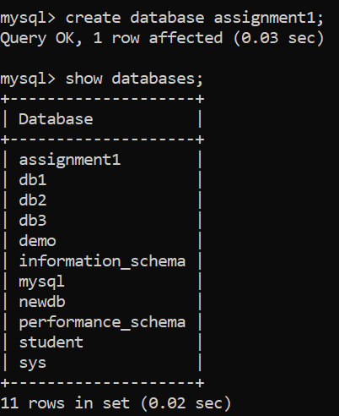

1. Write an SQL statement to create a simple table countries including columns country_id,country_name and region_id. After this display the structure of table as below :

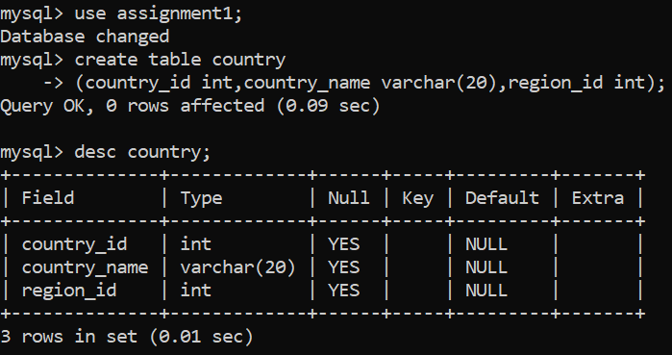

1. Write an SQL statement to create a table named jobs including columns job_id, job_title, min_salary, max_salary and check whether the max_salary amount exceeding the upper limit 25000. Also set job_id as primary key and entering null values for job_title is not allowed.

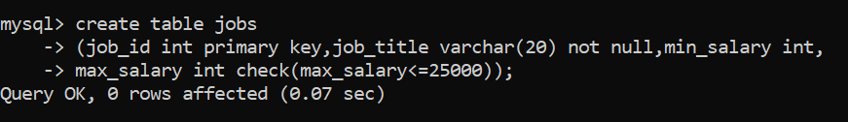

1. Write a SQL statement to create a table named job_histry including columns employee_id, start_date, end_date, job_id and department_id

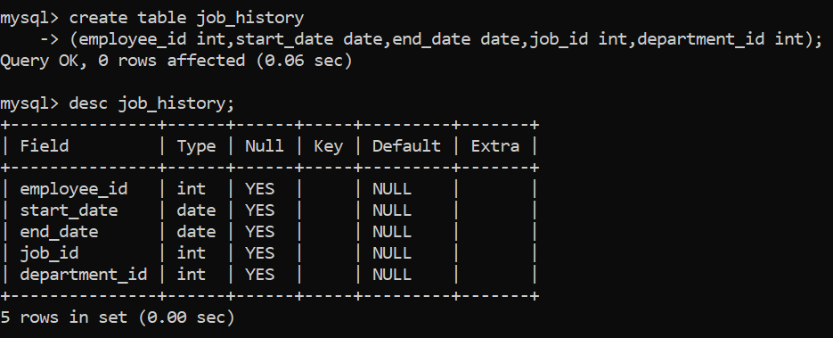

1. Write an SQL statement to alter a table named countries to make sure that no duplicate data against column country_id will be allowed at the time of insertion.

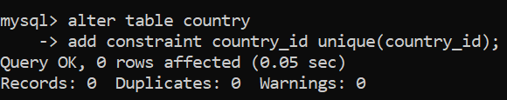

1. Write an SQL statement to create a table named jobs including columns job_id, job_title, min_salary and max_salary, and make sure that, the default value for job_title is blank and min_salary is 8000 and max_salary is NULL will be entered automatically at the time of insertion if no value assigned for the specified columns.

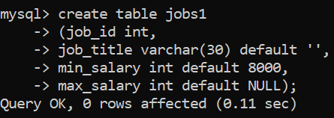

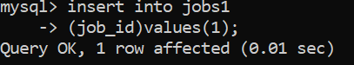

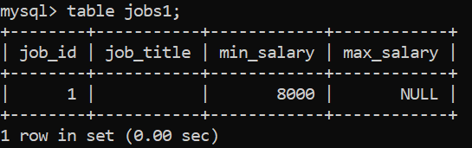

1. Create a Department table with following structure

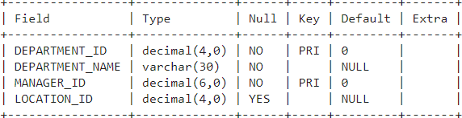

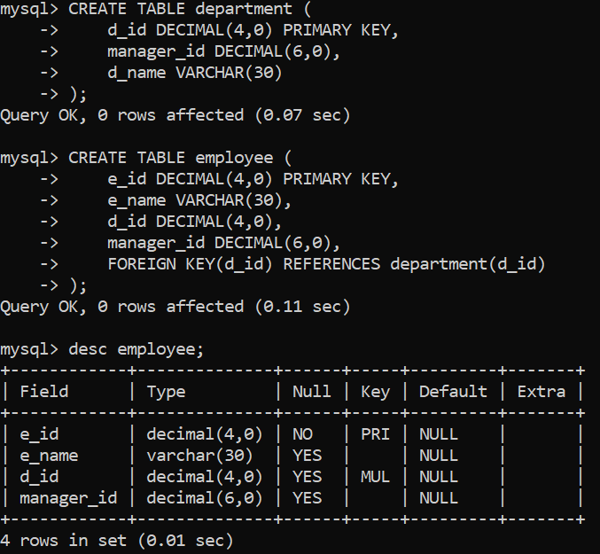

1. Write an SQL statement to create a table employees including columns employee_id, first_name, last_name, email, phone_number hire_date, job_id, salary, commission, manager_id and department_id and make sure that, the employee_id column does not contain any duplicate value at the time of insertion and the foreign key columns combined by department_id and manager_id columns contain only those unique combination values, which combinations are exists in the departments table.

